1. Programming Languages: C++ and JavaScript/QML
2. Variables and Classes:

Class simpleComputer:

Member Variables  
int pCount - Program Counter Variable  
int accum – Accumulator Variable  
int iReg – Instruction Register Variable  
int[100] mem – Memory spaces  
int[15] in – input cards

int[15] out – output cards

enum opCodes {INP, OUT, ADD, SUB, LDA, STA, JMP, TAC, SHF, HLT}

int tempValue – Variable used to hold values to be loaded to AC

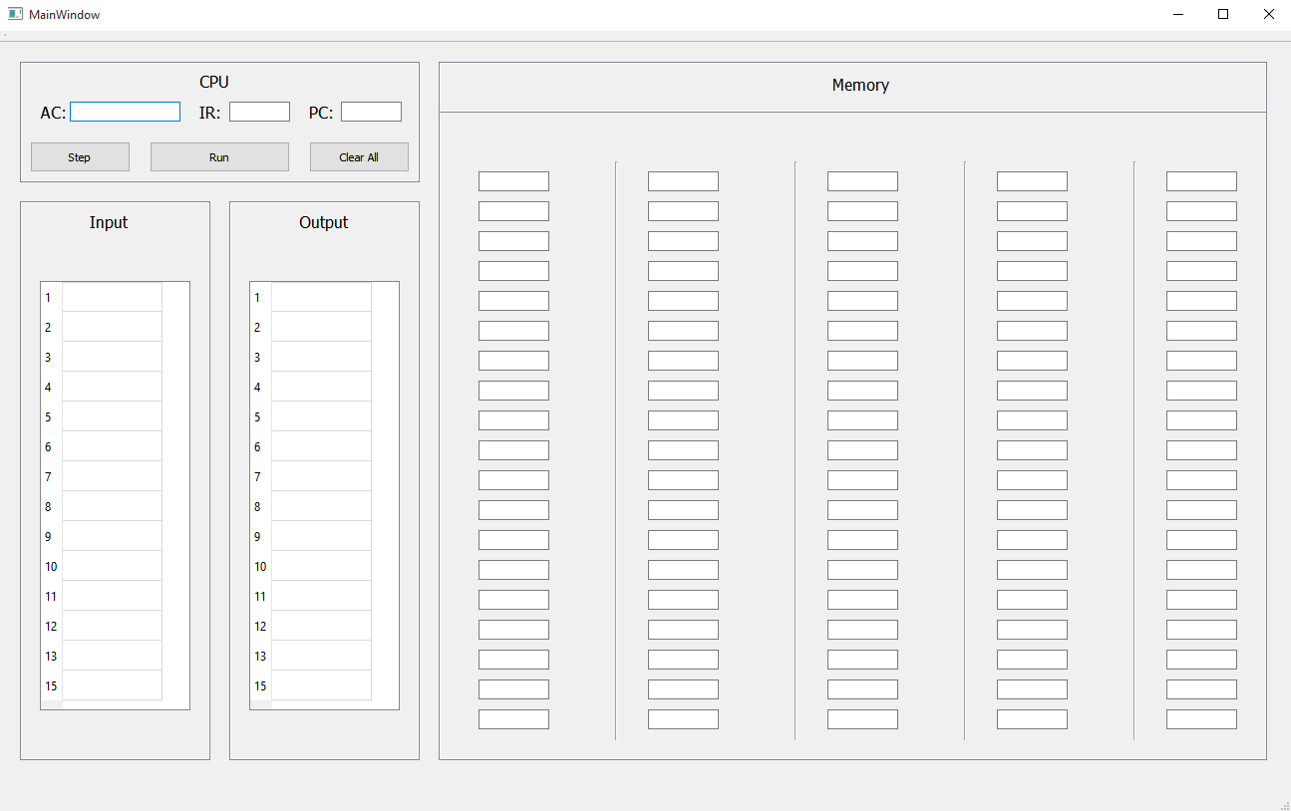 GUI Design Mock-Up:

1. Pseudocode to Run an Program in Memory

**Read** value(instructions) stored in mem[ pCount ]

**Load** instruction into iReg

**While** iReg != 9 _ _

**Interpret** value in iReg

**Execute** instruction

**Increment** pCount

**Read** value(instructions) stored in mem[ pCount ]

**Load** instruction into iReg

1. Pseudocode to Load data into Accumulator

**Assign** tempValue to accum.